RECOGNITION OF WATER FOR PEOPLE-CANADA

FISCAL YEAR 2015/16
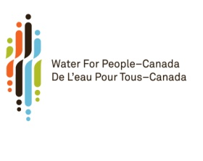

Thanks so much to our generous supporters
We are proud to recognize the following corporations, organizations and individuals for their Sponsor contributions during the period October 2015 - September 2016 under the following categories:

SPONSORSHIP LEVELS
EF Global Strategic Partners (1 Million plus)
-
EF Visionaries ($500,000 TO $499,999)
-
EF Champions ($250,000 TO $499,999)
-
EF Leaders ($100,000 TO $299,999)
Anonymous
EF Advocates ($50,000 TO $99,999)
-
EF Supporters ($20,000 - $49,999)
Atlantic Canada Water Works Association
BC Committee of WFP-C
Ontario Water Works Association
Western Canada Section AWWA
EF Friends ($1,000 - $19,999)
AECOM & Employees
Anonymous (2)
Atlantic Branch Equipment Association
CH2M Hill and Employees
City of Moncton
Geoff Reed
Graham Construction & Engineering
Halifax Regional Water Commission
Kerr Wood Leidal Associates Ltd.
Megan McAllister
MMM Group
Mohsen Mortada
OPCEA
Otto’s Service Centre
Otto’s Subaru
Peterborough Utilities
RBC Foundation
RESEAU/AQTE
Don Hoekstra “Ride With Purpose“
Peter Turgoose “Ride With Purpose”
Water Environment Association of Ontario
Whitson Contracting Ltd.
WSP Canada Inc. – Ontario
In-kind Supporters
CH2M Hill
ES&E Magazine

